DIGITAL BOOK

MARKET

Blibli ***FUTURE*** Program Batch 4.0

Fase 1 – Medan Kota



Oleh:

Andrew Wijaya

Muhamad Baihaqi

Syntia

REQUIREMENT DOCUMENT

# Pendahuluan

## Tujuan dan Ruang Lingkup Software

Tujuan dari pembuatan web ini adalah untuk membuat sebuah web yang menjual-belikan buku digital (*e-book*), yaitu versi elektronik dari buku. Dewasa ini, teknologi semakin canggih sehingga kebutuhan masyarakat akan hal-hal yang praktis juga meningkat. Kebutuhan untuk mendapatkan buku dengan cepat, serta mudah untuk dibawa juga meningkat pesat.

Buku digital lebih disukai karena lebih praktis jika dibandingkan dengan buku. Selain itu, terdapat fitur pencarian pada buku digital, sehingga kata-kata dalam buku digital dapat dengan cepat dicari dan ditemukan.

Dengan adanya web Digital Book Market, masyarakat diharapkan akan lebih mudah untuk melakukan transaksi jual-beli buku digital, tanpa perlu pergi ke toko yang bersangkutan.

## Definisi

Beberapa definisi kata yang akan sering dipakai :

**Admin** Orang yang dapat mengedit, menambah, atau menghapus data pada sistem; mengakses halaman master.

**Block** Proses memblokir suatu akun; mencabut hak akses dari suatu akun.

**Cart** Keranjang; menyimpan daftar order User.

**Catalog** Daftar koleksi sebuah / beberapa pusat dokumentasi yang disusun menurut sistem tertentu.

**Categories** Kategori; mengelompokkan produk berdasarkan tipe/kategori nya.

**Data** Informasi yang berupa fakta; deskripsi dari suatu kejadian yang dihadapi.

**Database** Sistem yang menyimpan semua informasi yang dimonitor oleh sistem ini.

**ERD** *Entity Relationship Diagram*; Diagram yang menunjukkan

**Home** Halaman utama yang ditampilkan sistem.

**Log in** Mengakses sistem dengan memasukkan identitas dari akun pengguna dan kata sandi untuk mendapatkan hak akses akun.

**Log out** Keluar dari akun yang sedang aktif pada sistem.

**Master Data** Data utama yang harus dibuat dengan benar supaya transaksi bisa dilakukan

**Merchant** Orang yang dapat menambah produk dan menjual produk dalam web.

**Profile** Berisi informasi User.

**Order** Melakukan pemesanan terhadap suatu produk.

**Rating** Memberi penilaian kuantitatif terhadap suatu produk.

**Review** Memberi penilaian dan/atau ulasan terhadap suatu produk.

**Search** Melakukan pencarian produk berdasarkan judul / kata kunci.

**SRS** *Software Requirement Specification*; Suatu dokumen yang mendeskripsikan semua fungsi dari sistem yang diusulkan dan kendala yang terjadi ketika sistem beroperasi, seperti dokumen ini.

**User** Orang yang mengunjungi / menggunakan web sebagai seorang konsumen.

**Wishlist** Daftar yang menyimpan produk favorit User.

## Referensi

Adapun referensi yang digunakan dalam membantu proses pembuatan dokumen SRS ini :

* [*http://cheesterzone.blogspot.com/2011/04/dokumen-srs-sistem-informasi.html*](http://cheesterzone.blogspot.com/2011/04/dokumen-srs-sistem-informasi.html)
* [*https://hasrulbakri.wordpress.com/2011/05/23/contoh-dokumen-srs-software-requirement-spesification/*](https://hasrulbakri.wordpress.com/2011/05/23/contoh-dokumen-srs-software-requirement-spesification/)
* http://www.cse.msu.edu/~chengb/RE-491/Papers/SRSExample-webapp.doc

## Sistematika

Dokumen SRS ini dibagi menjadi tiga bagian utama, yaitu :

**Pendahuluan**, berisi penjelasan tentang tujuan pembuatan dan lingkup masalah yang dipengaruhi oleh web yang dikembangkan, definisi, referensi dan sistematika.

**Deskripsi Umum**, berisi penjelasan secara umum mengenai web yang akan dikembangkan, meliputi perspektif deskripsi umum sistem,karakteristik penggauna, batasan-batasan dan asumsi penggunaan.

**Spesifikasi Kebutuhan**, berisi uraian kebutuhan web secara lebih rinci.

# Deskripsi Umum

## Perspektif

Produk yang berupa situs web ditujukan kepada para pengguna (konsumen dan para penjual) buku digital. Semua pengguna (baik pengguna terdaftar maupun anonim) akan mengakses dengan menggunakan situs web ini.

Pengguna tidak diharuskan mendaftar jika pengguna hanya berkunjung ke web. Namun untuk dapat menggunakan semua fungsi yang disediakan, pengguna diminta untuk mendaftar melalui antarmuka web. Ketika pengguna baru mendaftar, semua data yang diminta akan disimpan dalam database dan sebuah workspace akan diberikan pada pengguna. Nantinya, pengguna dapat melakukan login ke / logout dari sistem kapanpun.

Dari sudut pandang pengguna sebagai konsumen, pengguna diharapkan dapat melihat dan mencari buku berdasarkan kategori yang tersedia, melihat buku yang sudah pernah dibeli, menyimpan daftar buku yang ingin dibeli, membeli buku, dan membaca buku yang sudah dibeli.

Sementara dari sudut pandang pengguna sebagai penjual, pengguna diharapkan dapat memasukkan produk, melihat halaman tokonya, serta melihat daftar pengguna yang memesan buku dari toko penjual.

## Kegunaan

Produk memungkinkan User dan Merchant untuk melakukan transaksi jual-beli buku digital secara online.

Fungsi-fungsi dari produk adalah :

|  |  |  |
| --- | --- | --- |
| User | Merchant | Admin |
| Login  Profile  Product  Wishlist  Purchase and Order List  Cart  Book Library | Login  Storefront Page  Catalog Entry  Product  Incoming Order | Login  Master Page  Block User |

## Karakteristik Pengguna

Berikut adalah 3 jenis pengguna beserta karakteristiknya yang akan menggunakanproduk.

|  |  |
| --- | --- |
| **Pengguna** | **Karakteristik** |
| User | User dapat melihat dan mencari buku digital yang tersedia, membeli buku digital melalui pembayaran online, dan membaca buku yang sudah dibeli. |
| Merchant | Merchant dapat menambah buku digital yang ingin dijual, menampilkan halaman profil, dan menerima orderan yang datang. |
| Admin | Admin dapat mengubah data, mengakses halaman master, serta dapat melakukan *block* pada User maupun Merchant. |

## Batasan-Batasan

Beberapa batasan dalam menggunakan web ini :

* User yang dapat melihat / mengubah *Wishlist*, melihat *Book Library*, melihat / mengubah keranjang (*Cart*), melakukan pembayaran, dan memberi ulasan pada produk adalah User yang sudah terdaftar.

## Asumsi dan Ketergantungan

Asumsi dan ketergantungan dalam menggunakan web ini :

* Pengguna sudah mengerti dalam memakai layanan *e-commerce*
* Semua pembayaran yang dilakukan secara otomatis akan berhasil

# Spesifikasi Kebutuhan

## Kebutuhan Fungsional

Berikut adalah Use Case Diagram dari masing-masing role.

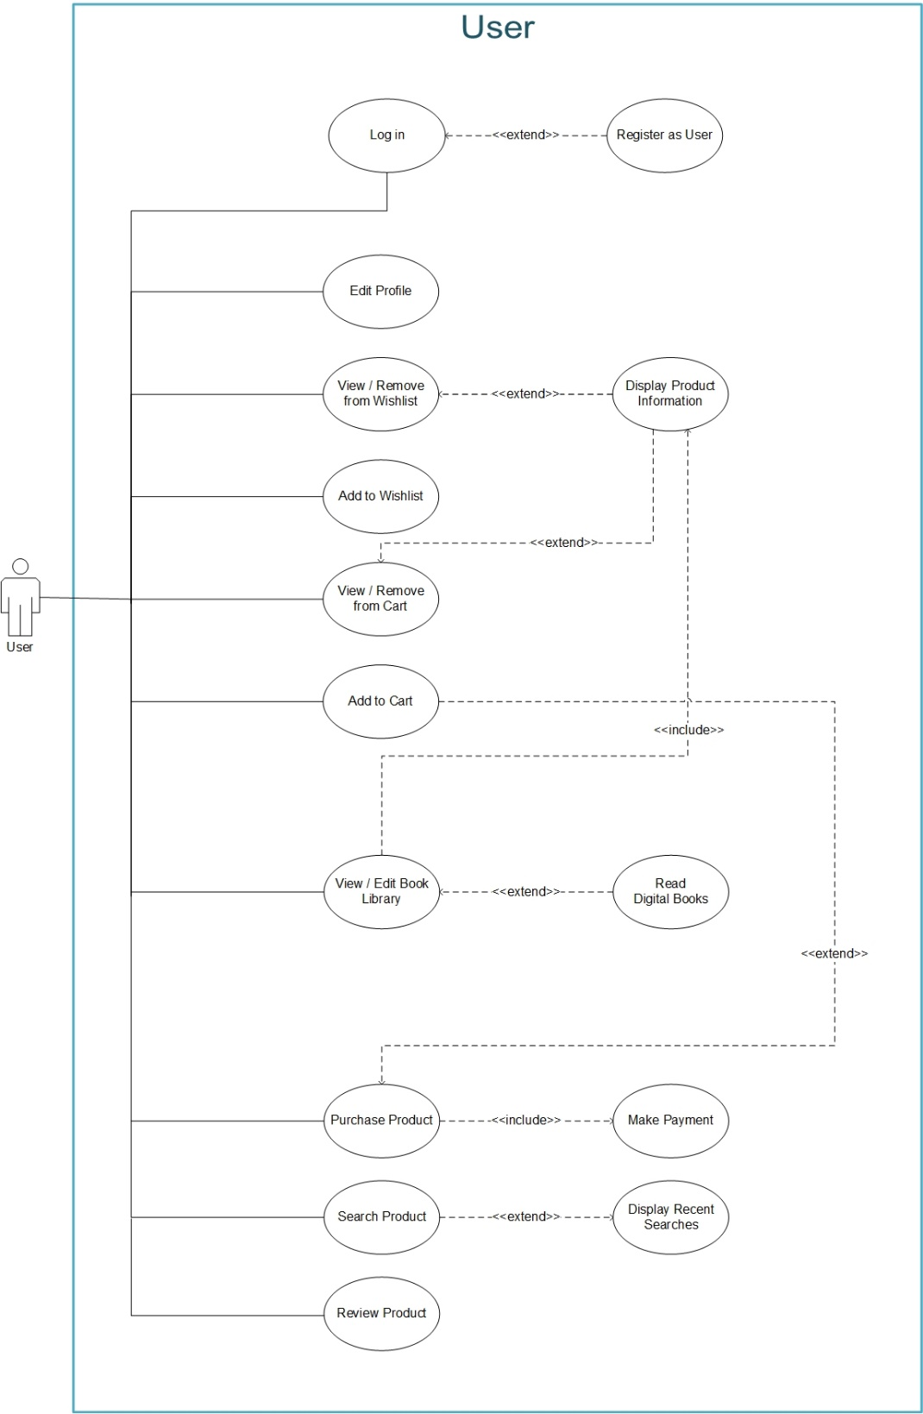

Gambar Use Case Diagram for User

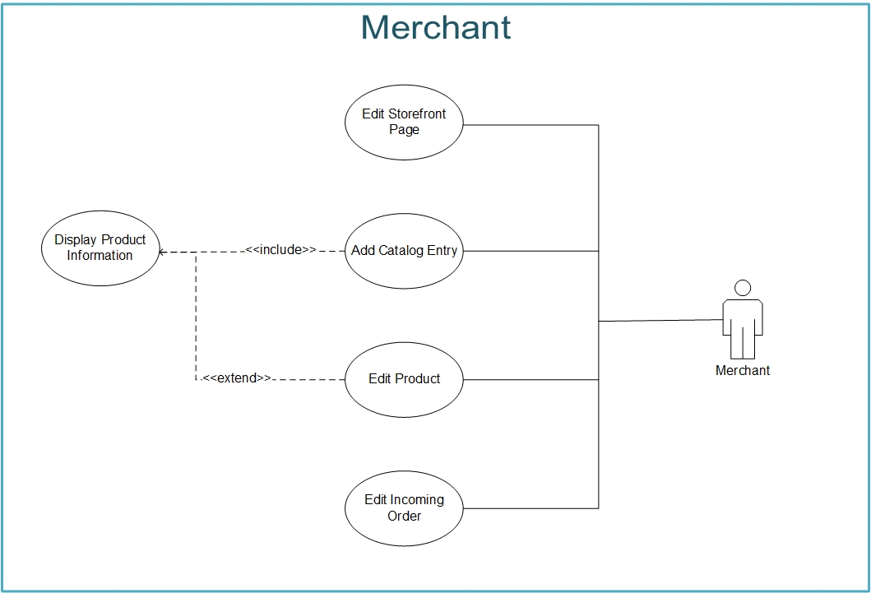

Gambar Use Case Diagram for Merchant

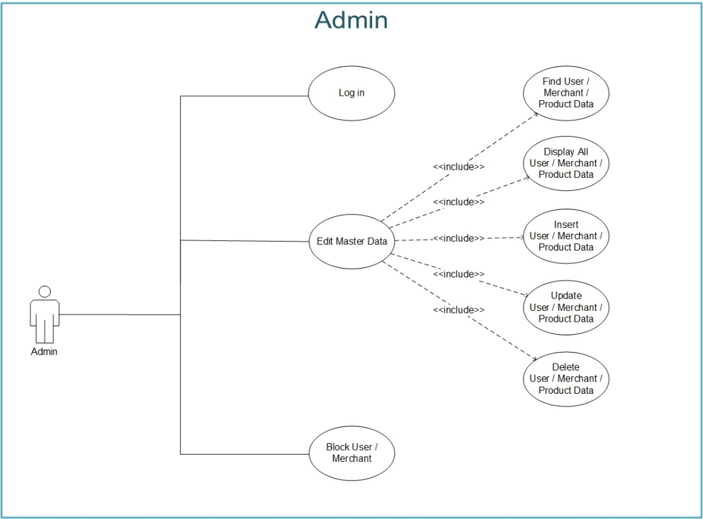

Gambar Use Case Diagram for Admin

Berikut deskripsi dari Use Case Diagram di atas.

### Log in

|  |  |  |
| --- | --- | --- |
| Use Case Name | Log in | |
| Scenario | Login an account to use the web | |
| Triggering Event | Clicking some features that only available to verified account.  Clicking Log in / Register menu. | |
| Brief Description | User must log in to use all of the provided features and have an account.  Merchant and Admin must log in before using the web and have an account. | |
| Actors | User, Merchant, Admin | |
| Pre-conditions | User, Merchant, Admin hasn’t logged in | |
| Post-conditions | User, Merchant, Admin has logged in | |
| Flow of Activities | **Actor** | **System** |
| 1. User, Merchant, Admin click Log in / Register menu | * 1. System loads the UI for login |
| 1. User, Merchant, Admin type the username and password |  |
| 1. User, Merchant, Admin click on login button | * 1. System validates the username and password   2. System informs the user of successful login by show the home UI for each role.   3. System loads the home UI. |
| Exceptions Conditions | * 1. User, Merchant, Admin failed to Log in due to unstable Internet connection.   2. User, Merchant, Admin failed to Log in caused by wrong username / password.   3. User, Merchant failed to Log in because the account is blocked from the system. | |

### Register as User / Merchant

|  |  |  |
| --- | --- | --- |
| Use Case Name | Register as User / Merchant | |
| Scenario | Register as an User / a Merchant | |
| Triggering Event | Clicking Log in / Register menu.  Clicking Register menu. | |
| Brief Description | User / Merchant input all the required field such as username, email, password. | |
| Actors | User, Merchant | |
| Pre-conditions | User, Merchant hasn’t have an account | |
| Post-conditions | User, Merchant has an account and has logged in. | |
| Flow of Activities | **Actor** | **System** |
| 1. User / Merchant click Log in / Register menu | * 1. System loads the UI for login |
| 1. User / Merchant type all the required information, such as username and password. |  |
| 1. User / Merchant click on Sign up button | * 1. System validates all the field in form   2. System successfully registered an account in database   3. System automatically logged in the User / Merchant by show the home UI for each role. |
| Exceptions Conditions | 3.2. User / Merchant failed to register due to an error in some field, such as username already exists. | |

### Edit Profile

|  |  |  |
| --- | --- | --- |
| Use Case Name | Edit Profile User | |
| Scenario | View or Edit Profile of an User account | |
| Triggering Event | Clicking Profile menu.from Hamburger icon.  Clicking Profile photo on Review button in Product page (if user has reviewed on a product) | |
| Brief Description | User fill/edit their personal information such as Address, Phone Number, etc. | |
| Actors | User | |
| Pre-conditions | User hasn’t complete / change their personal information | |
| Post-conditions | User has completed / changed their personal information | |
| Flow of Activities | **Actor** | **System** |
| 1. User click Profile menu | * 1. System loads the UI for edit profile |
| 1. User fill / change some or all the required information, such as Address, Phone Number. |  |
| 1. User click on checklist (Done) button. | * 1. System successfully filled / changed the information in database   2. System redirects to Home UI |
| Exceptions Conditions | 3.1. User failed to change / fill the information due to unstable Internet connection. | |

### Edit Storefront Page

|  |  |  |
| --- | --- | --- |
| Use Case Name | Edit Storefront Page | |
| Scenario | View or Edit Storefront Page of a Merchant account | |
| Triggering Event | Clicking Edit button on Storefront Page.  Clicking Profile photo on Product page (if merchant has added a product or more). | |
| Brief Description | Merchant fill/edit their storefront information such as Store Name, Phone Number, etc. | |
| Actors | Merchant | |
| Pre-conditions | Merchant hasn’t complete / change their storefront information | |
| Post-conditions | Merchant has completed / changed their storefront information | |
| Flow of Activities | **Actor** | **System** |
| 1. Merchant click the Edit button on Storefront Page. | * 1. System loads the UI for edit Storefront information. |
| 1. Merchant fill / change some or all the required information, such as Address, Phone Number. |  |
| 1. Merchant click on checklist (Done) button. | * 1. System successfully filled / changed the information in database   2. System redirects to Storefront UI. |
| Exceptions Conditions | * 1. Merchant failed to change / fill the information due to unstable Internet connection. | |

### View / Remove from Wishlist

|  |  |  |
| --- | --- | --- |
| Use Case Name | View / Remove from Wishlist | |
| Scenario | View or Remove favorite product from their Wishlist. | |
| Triggering Event | Clicking Wishlist menu on Hamburger menu. | |
| Brief Description | User be able to view, or remove their favorite product from their Wishlist. | |
| Actors | User | |
| Pre-conditions | User hasn’t remove their favorite product from their Wishlist. | |
| Post-conditions | User has removed their favorite product from their Wishlist. | |
| Flow of Activities | **Actor** | **System** |
| 1. User click the Wishlist menu from Hamburger menu | * 1. System loads the UI for view, edit, or remove from Wishlist. |
| 1. User click Remove button on a wishlist | * 1. System removed the product from User’s Wishlist and from the database. |
| Exceptions Conditions | * 1. User failed to remove the product due to unstable Internet connection. | |

### Add to Wishlist

|  |  |  |
| --- | --- | --- |
| Use Case Name | Add to Wishlist | |
| Scenario | Add favorite product to their Wishlist. | |
| Triggering Event | Clicking “Add to Wishlist” button at Product Page. | |
| Brief Description | User be able to add their favorite product to their Wishlist from Product Page. | |
| Actors | User | |
| Pre-conditions | User hasn’t add their favorite product to their Wishlist. | |
| Post-conditions | User has added their favorite product to their Wishlist. | |
| Flow of Activities | **Actor** | **System** |
|  | 1. User click the “Add to Wishlist” button at Product Page. | * 1. System adds the product to User’s wishlist and to the database   2. System displays pop-up message indicates system successfully added the product to their wishlist. |
| Exceptions Conditions | * 1. User failed to add the product due to unstable Internet connection. | |

### View / Remove from Cart

|  |  |  |
| --- | --- | --- |
| Use Case Name | View / Remove from Cart | |
| Scenario | View or Remove the products from User’s Cart. | |
| Triggering Event | Clicking Cart icon at Navigation Pane. | |
| Brief Description | User be able to view, or remove product from their Cart. | |
| Actors | User | |
| Pre-conditions | User hasn’t remove the products from their Cart. | |
| Post-conditions | User has removed the products from their Cart. | |
| Flow of Activities | **Actor** | **System** |
| 1. User click the Cart icon at Navigation Pane. | * 1. System loads the UI for view, or remove from Cart. |
| 1. User click Remove button on a Cart. | * 1. System removed the product from User’s Cart and from the database. |
| Exceptions Conditions | * 1. User failed to remove the product due to unstable Internet connection. | |

### Add to Cart

|  |  |  |
| --- | --- | --- |
| Use Case Name | Add to Cart | |
| Scenario | Add the product to User’s Cart. | |
| Triggering Event | Clicking “Add to Cart” button at Product Page. | |
| Brief Description | User be able to add their favorite product to the Cart from Product Page. | |
| Actors | User | |
| Pre-conditions | User hasn’t add their favorite product to the Cart. | |
| Post-conditions | User has added their favorite product to the Cart. | |
| Flow of Activities | **Actor** | **System** |
| 1. User click the “Add to Cart” button at Product Page. | * 1. System adds the product to User’s cart and to the database.   2. System displays pop-up message indicates system successfully added the product to the cart. |
| Exceptions Conditions | * 1. User failed to add the product due to unstable Internet connection. | |

### View / Edit Book Library

|  |  |  |
| --- | --- | --- |
| Use Case Name | View / Edit Book Library | |
| Scenario | View or Edit User’s Book Library, to see purchased products. | |
| Triggering Event | Clicking “My Book Library” or “View more” at User’s Home page. | |
| Brief Description | User be able to see their Book Library and read the books from the Book Library. | |
| Actors | User | |
| Pre-conditions | User hasn’t see their Book Library, or hasn’t read the purchased books. | |
| Post-conditions | User has seen their Book Library, or has read the purchased books. | |
| Flow of Activities | **Actor** | **System** |
| 1. User click “My Book Library” or “View more” at User’s Home page. | * 1. System loads the UI for User’s Book Library. |
| 1. User click “Read Now” button at a product. | * 1. System re-direct to pdf opener, then the pdf opener opens the file. |
| Exceptions Conditions | 2.1. User can’t open the book due to unstable Internet connection.  2.1. User can’t open the book because the book is blocked / not available. | |

### Purchase Product

|  |  |  |
| --- | --- | --- |
| Use Case Name | Purchase Product | |
| Scenario | Purchase the Product from User’s Cart, or from the Product Page. | |
| Triggering Event | Clicking “Purchase Now” button at Product Page.  Clicking “Purchase Now” button at User’s Cart. | |
| Brief Description | User be able to purchase the product from User’s Cart. | |
| Actors | User | |
| Pre-conditions | User hasn’t purchase the selected products from User’s Cart. | |
| Post-conditions | User has purchased the selected products from User’s Cart. | |
| Flow of Activities | **Actor** | **System** |
| 1. User click the “Purchase Now” button at Product Page, or at User’s Cart | * 1. System loads the UI for Purchase page. |
| 1. User chooses a payment method. |  |
| 1. User clicks the “Make Payment” button to order the product(s). | * 1. System added User’s order to the Order List and to the database.   2. System gives the product access rights to the user. |
| Exceptions Conditions | 3.1. User failed to purchase the product due to unstable Internet connection. | |

### Search Product

|  |  |  |
| --- | --- | --- |
| Use Case Name | Search Product | |
| Scenario | Search the available Product by title, or keyword. | |
| Triggering Event | Clicking Search button on navigation pane. | |
| Brief Description | User and Merchant be able to find the available Product by title, or by keyword. | |
| Actors | User, Merchant | |
| Pre-conditions | User and Merchant hasn’t find a specific product. | |
| Post-conditions | User and Merchant has found a specific product. | |
| Flow of Activities | **Actor** | **System** |
| 1. User click the Search icon on the navigation panel. | * 1. System loads the UI for Search Product. |
| 1. User type the keyword or title of the product. |  |
| 1. User click the Search icon. | 3.1. System shows all products related to the search keyword. |
| Exceptions Conditions | * 1. User failed to search the product due to unstable Internet connection.   2. User failed to search the product because search keyword didn’t match any available product. | |

### Review Product

|  |  |  |
| --- | --- | --- |
| Use Case Name | Review Product | |
| Scenario | Rate and/or Write a Review about the Product. | |
| Triggering Event | Clicking Review icon at Product Details Page. | |
| Brief Description | User be able to Rate and/or write a Review about the Product. | |
| Actors | User | |
| Pre-conditions | User hasn’t rate and/or write a review about the product. | |
| Post-conditions | User has rated and/or written a review about the product. | |
| Flow of Activities | **Actor** | **System** |
| 1. User click the Review icon at Product Details Page. | * 1. System loads the UI for view, edit, or remove from Wishlist. |
| 1. User rate and/or write a review about the product |  |
| 1. User click Submit button to finish the review. | * 1. System successfully added the review to Product Details Page and to the database. |
| Exceptions Conditions | 3.1. User failed to review the product due to unstable Internet connection. | |

### Add Catalog Entry

|  |  |  |
| --- | --- | --- |
| Use Case Name | Add Catalog Entry | |
| Scenario | Add new Catalog Entry (Products). | |
| Triggering Event | Clicking “Add Product” button on Storefront Page. | |
| Brief Description | Merchant be able to add new product to their Store. | |
| Actors | Merchant | |
| Pre-conditions | Merchant hasn’t add new product to their Store. | |
| Post-conditions | Merchant has added new product to their Store. | |
| Flow of Activities | **Actor** | **System** |
| 1. Merchant click “Add Product” icon on Storefront Page. | * 1. System loads the UI for add Catalog Entry. |
| 1. Merchant fill the details of the product. |  |
| 1. Merchant click Add button to finish adding product. | * 1. System successfully added the product to the database and to Merchant’s Store.   2. System automatically re-direct to the Storefront Page. |
| Exceptions Conditions | * 1. Merchant failed to add the product due to unstable Internet connection. | |

### Edit Product

|  |  |  |
| --- | --- | --- |
| Use Case Name | Edit Product | |
| Scenario | Edit product information from Product Page. | |
| Triggering Event | Clicking “Edit” button on Product Page. | |
| Brief Description | Merchant be able to Edit product information. | |
| Actors | Merchant | |
| Pre-conditions | Merchant hasn’t change information of the product. | |
| Post-conditions | Merchant has changed information of the product. | |
| Flow of Activities | **Actor** | **System** |
| 1. Merchant click Edit button on Product Detail Page. | * 1. System change some field from read-only to editable field. |
| 1. Merchant edit any field needed to change. |  |
| 1. Merchant click Checklist / Submit button to finish editing product information. | * 1. System successfully update edited field to the Product Page and to the database.   2. System re-direct recent UI to Product Page. |
| Exceptions Conditions | * 1. Merchant failed to edit information of the product due to unstable Internet connection. | |

### Edit Incoming Order

|  |  |  |
| --- | --- | --- |
| Use Case Name | Edit Incoming Order | |
| Scenario | Approve or reject incoming order from User. | |
| Triggering Event | Clicking “Incoming Order” menu from Hamburger menu. | |
| Brief Description | Merchant be able to approve or reject incoming order from User. | |
| Actors | Merchant | |
| Pre-conditions | Merchant hasn’t approve or reject incoming order from User. | |
| Post-conditions | Merchant has approved or rejected incoming order from User. | |
| Flow of Activities | **Actor** | **System** |
| 1. Merchant click “Incoming Order” menu from Hamburger menu | * 1. System loads the UI for Incoming Order. |
| 1. Merchant select incoming order to approve / reject. |  |
| 1. Merchant click Approve / Reject button. | * 1. System updates Merchant’s incoming order.   2. System updates User’s Order List. |
| Exceptions Conditions | * 1. Merchant failed to approve / reject incoming order due to unstable Internet connection.   2. Merchant failed to approve / reject incoming order because the order is cancelled by User. | |

### Edit Master Data

|  |  |  |
| --- | --- | --- |
| Use Case Name | Edit Master Data | |
| Scenario | Access / Edit master data. | |
| Triggering Event | Log in using admin account. | |
| Brief Description | Admin be able to find, find all, insert, update, and delete master data. | |
| Actors | Admin | |
| Pre-conditions | Admin hasn’t find, find all, insert, update, or delete master data. | |
| Post-conditions | Admin has found, found all, inserted, updated, or deleted master data. | |
| Flow of Activities | **Actor** | **System** |
| 1. Admin successfully logged in to the system. | * 1. System loads the home UI. |
| 1. Admin click Hamburger menu to find, find all, insert, update, or delete data. | * 1. System loads the UI for find, find all, insert, update, or delete data. |
| 1. Admin insert, update, or delete the data. | * 1. System validates the change format.   2. System successfully insert, update, or delete data from the system. |
| Exceptions Conditions | * 1. Admin failed to insert, update, or delete data due to invalid field format.   2. Admin failed to insert, update, or delete data due to unstable Internet connection. | |

### Block User / Merchant

|  |  |  |
| --- | --- | --- |
| Use Case Name | Block User / Merchant | |
| Scenario | Block / Unblock User or Merchant from the system. | |
| Triggering Event | Clicking “Block User / Merchant” menu from Hamburger menu. | |
| Brief Description | Admin be able to block / unblock the User / Merchant from the system. | |
| Actors | Admin | |
| Pre-conditions | Admin hasn’t block / unblock an user / a merchant from the system. | |
| Post-conditions | Admin has blocked / unblocked an user / a merchant from the system. | |
| Flow of Activities | **Actor** | **System** |
| * 1. Admin click “Block User / Merchant” menu from Hamburger menu. | * 1. System re-direct to the Search UI. |
| 1. Admin click User / Merchant from the search results | * 1. System loads UI for User / Merchant profile. |
| 1. Admin click the “Block” / “Unblock” button. | * 1. System checks whether User / Merchant status, active or suspend.   2. System changes User / Merchant status from active to suspend and vice versa. |
| Exceptions Conditions | * 1. Admin failed to Block User / Merchant due to unstable internet connection. | |

### Log out

|  |  |  |
| --- | --- | --- |
| Use Case Name | Log out | |
| Scenario | Log out from an account | |
| Triggering Event | Clicking Log out menu from Hamburger menu (if a User / Merchant / Admin is logged in). | |
| Brief Description | User / Merchant / Admin log out from their account. | |
| Actors | User, Merchant, Admin | |
| Pre-conditions | User, Merchant, Admin is still logged in. | |
| Post-conditions | User, Merchant, Admin has logged out. | |
| Flow of Activities | **Actor** | **System** |
| 1. User / Merchant / Admin click the Log out menu from Hamburger menu. | * 1. System saves all the event that User / Merchant / Admin has done to the database.   2. System resets the active account from the web, then system automatically redirected the page to the Home page. |
| Exceptions Conditions | User / Merchant / Admin failed to log out due to unstable Internet connection. | |

## Kebutuhan Antarmuka Eksternal

### Kebutuhan Antarmuka Pengguna

Antarmuka pengguna harus bisa berinteraksi dengan antarmuka yang ditampilkan sistem pada layar *smartphone* Android (utama), laptop, komputer, tablet, dan sebagainya.

### Kebutuhan Antarmuka Perangkat Keras

Perangkat keras yang digunakan harus mampu untuk terhubung dengan koneksi internet, serta memiliki daya yang cukup.

### Kebutuhan Antarmuka Perangkat Lunak

Perangkat lunak yang dibutuhkan untuk mengoperasikan perangkat lunak ialah:

* Sistem Operasi

Android, tablet : 4.3 (Jelly Bean)

Laptop, komputer : Windows 7

* Database : PostgreSQL 11
* Koneksi database : pgAdmin 4

### Kebutuhan Antarmuka Komunikasi

Tidak diterapkan pada sistem ini.

## Kebutuhan Non-Fungsional

### Struktur Logikal Data

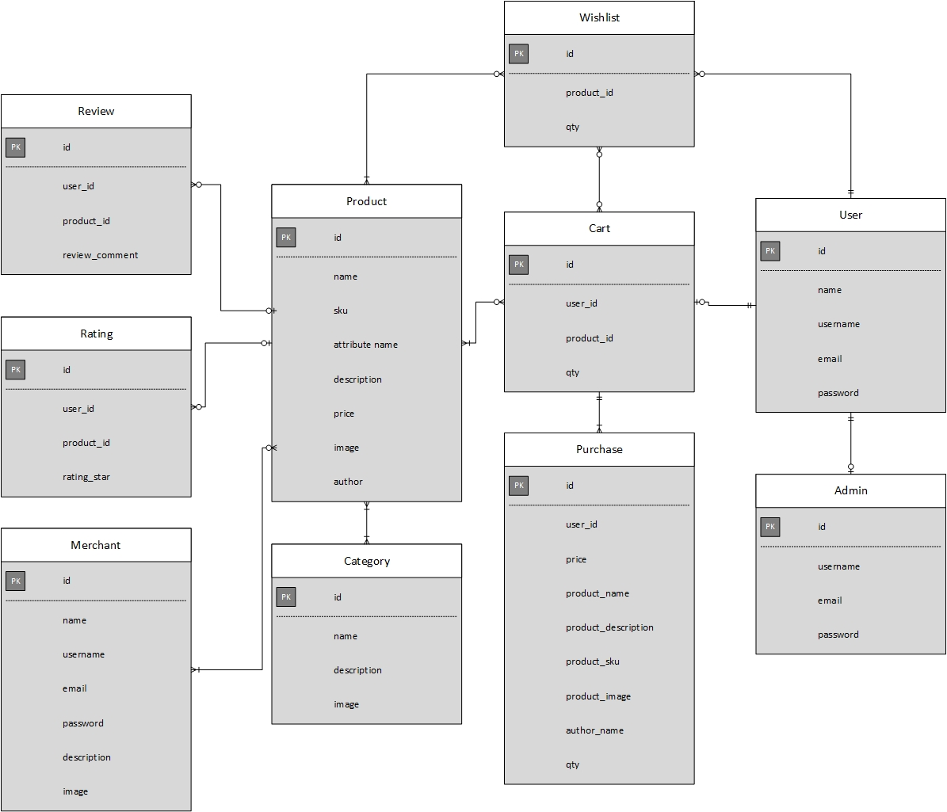

Gambar Entity-Relationship Diagram

# User Stories

#### User

Sebagai seorang User, saya ingin melakukan login / logout dari akun saya.

Sebagai seorang User, saya ingin mengedit profil / akun saya.

Sebagai seorang User, saya ingin melihat atau menghapus wishlist yang saya simpan.

Sebagai seorang User, saya ingin melakukan pembayaran.

Sebagai seorang User, saya ingin melihat semua buku yang sudah saya beli.

Sebagai seorang User, saya ingin membuka dan membaca buku yang sudah saya beli melalui web secara langsung.

Sebagai seorang User, saya ingin mencari buku dari kata kunci pada buku, atau dari judul buku.

Sebagai seorang User, saya ingin mengulas produk yang sudah saya beli.

#### Merchant

Sebagai seorang Merchant, saya ingin melihat atau mengedit profil toko saya.

Sebagai seorang Merchant, saya ingin melihat atau mengedit halaman produk saya.

Sebagai seorang Merchant, saya ingin melihat orderan produk saya yang datang.

Sebagai seorang Merchant, saya ingin melihat entri katalog.

#### Admin

Sebagai seorang Admin, saya ingin mengakses halaman master.

Sebagai seorang Admin, saya ingin menampilkan, menambah, meng-*update*, dan menghapus data produk.

Sebagai seorang Admin, saya ingin menampilkan, menambah, meng-*update*, dan menghapus data User / Merchant.

Sebagai seorang Admin, saya ingin menampilkan, menambah, meng-*update*, dan menghapus kategori produk.

Sebagai seorang Admin, saya ingin melakukan *block* pada user, baik User maupun Merchant.